Advanced Database Training
2026
Vaishnavi Kamthe

Assignment 1b
1. The HR department wants a query to display the first name, last name, hire date and employee number for each employee, with employee number appearing first. Provide an alias STARTDATE for the hire date column.
SELECT emp_no, first_name, last_name, hire_date AS STARTDATE
FROM employees;
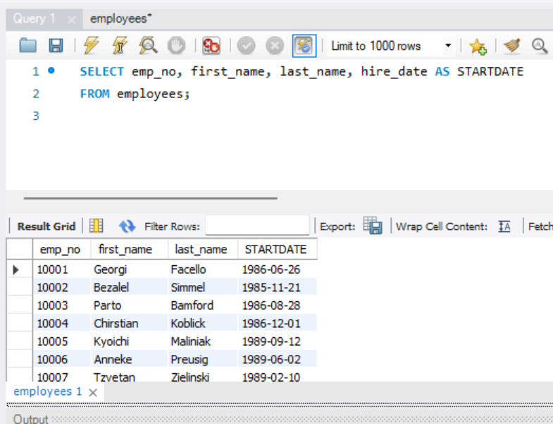
2. Display all employee details whose last name starts with the letter “a” or “A”.
SELECT *
FROM employees
WHERE last_name LIKE 'A%';
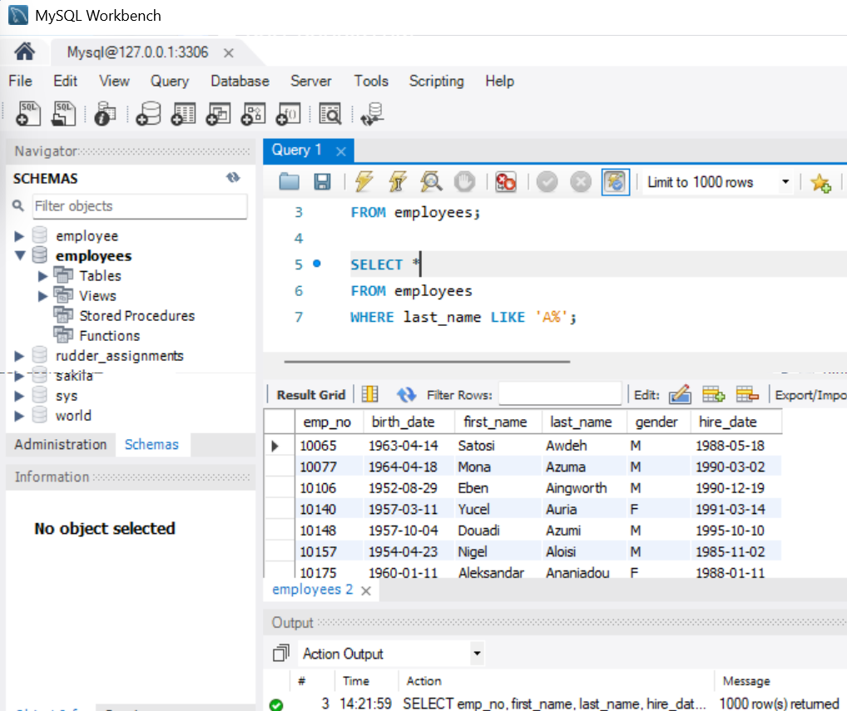
3. The HR department needs a report that displays the first name, last name and hire date for all employees who were hired in the year 1994.
SELECT first_name, last_name, hire_date
FROM employees
WHERE YEAR(hire_date) = 1994;
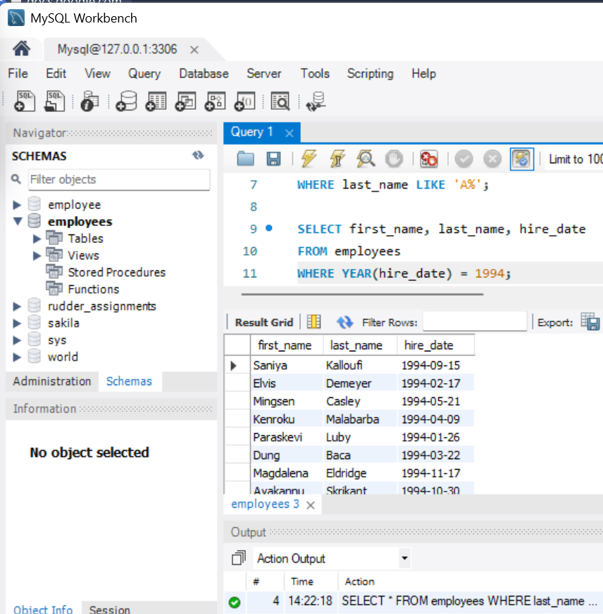
4. Display the first name, last name and department information for all current employees who work in the Human Resource department.
SELECT e.first_name, e.last_name, d.dept_name
FROM employees e
JOIN dept_emp de ON e.emp_no = de.emp_no
JOIN departments d ON d.dept_no = de.dept_no
WHERE d.dept_name = 'Human Resources'
AND de.to_date = '9999-01-01';
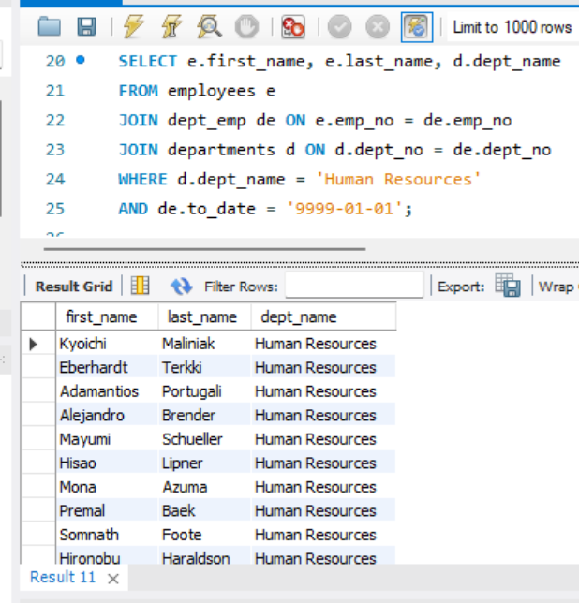
5. Write SQL query to display all employee records who have joined recently i.e. within the last 90 days from today.
SELECT *
FROM employees
WHERE hire_date >= CURDATE() - INTERVAL 90 DAY;
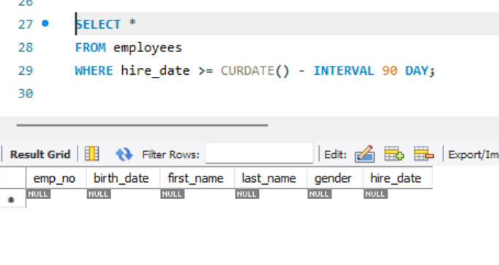
The dataset is old which is why there are no entries in the last 90 days
6. Write SQL queries to return count of current employees by each department and sort the results in descending order of count.
SELECT d.dept_name, COUNT(*) AS emp_count
FROM dept_emp de
JOIN departments d ON de.dept_no = d.dept_no
WHERE de.to_date = '9999-01-01'
GROUP BY d.dept_name
ORDER BY emp_count DESC;
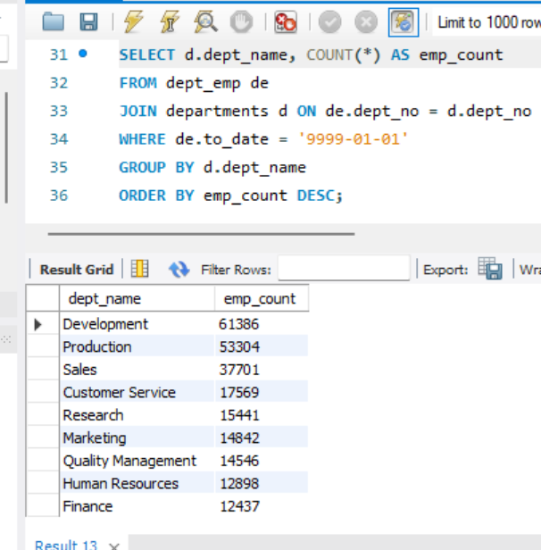
7. Write SQL queries to show top 100 distinct current employee details with their title and department information.
SELECT DISTINCT e.emp_no, e.first_name, e.last_name, t.title, d.dept_name
FROM employees e
JOIN titles t ON e.emp_no = t.emp_no
JOIN dept_emp de ON e.emp_no = de.emp_no
JOIN departments d ON d.dept_no = de.dept_no
WHERE t.to_date = '9999-01-01'
AND de.to_date = '9999-01-01'
LIMIT 100;
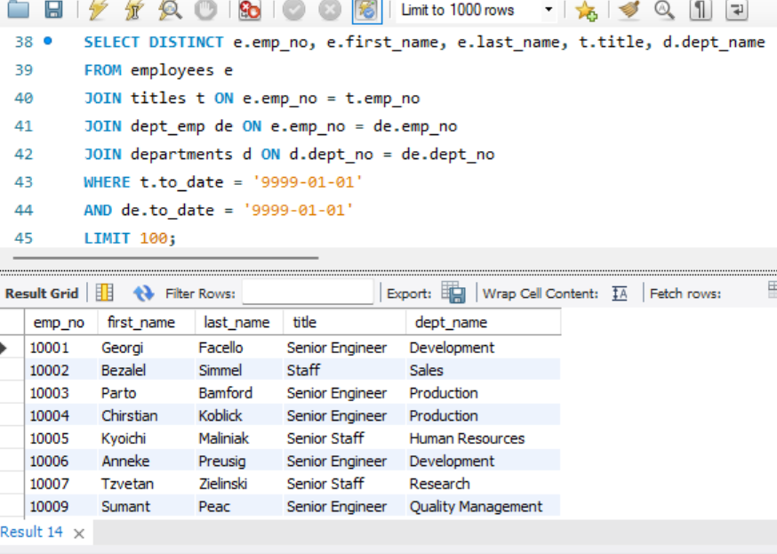
8. The HR department needs a report to display the current employee number, last name, salary, and salary increased by 15.5% for each employee.
SELECT e.emp_no, e.last_name, s.salary,
ROUND(s.salary * 1.155, 2) AS increased_salary
FROM employees e
JOIN salaries s ON e.emp_no = s.emp_no
WHERE s.to_date = '9999-01-01';
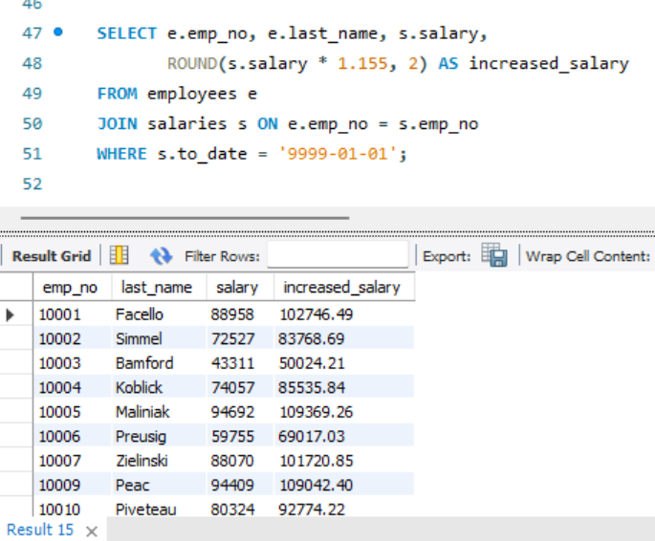
9. The HR department wants to find the duration of employment for current employees till date.
For each current employee, display the last name and calculate the number of months between today and the date on which the employee was hired.
Label the column as MONTHS_WORKED. Order your results by the number of months employed. Round the number of months up to the closest whole number.
SELECT last_name,
CEIL(TIMESTAMPDIFF(MONTH, hire_date, CURDATE())) AS MONTHS_WORKED
FROM employees
ORDER BY MONTHS_WORKED;
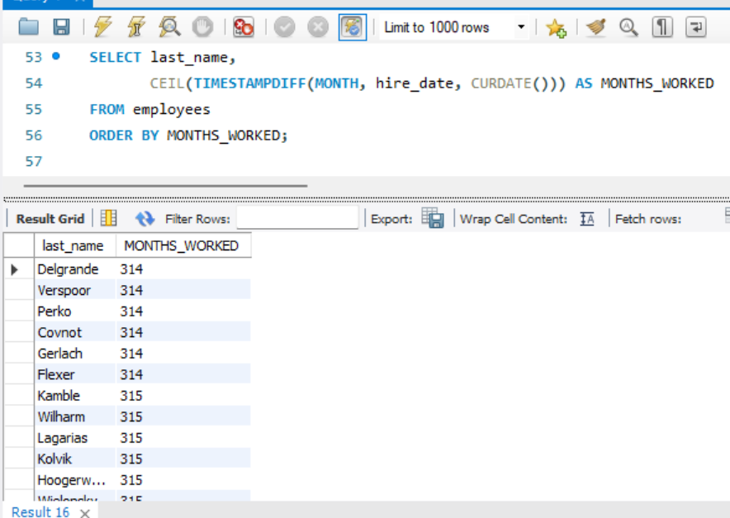
10. Write a query to display the last name and salary for all current employees. Format the salary to be 15 characters long, left-padded with the $ symbol. Label the column as SALARY.
SELECT last_name,
LPAD(CONCAT('$', salary), 15, '$') AS SALARY
FROM employees e
JOIN salaries s ON e.emp_no = s.emp_no
WHERE s.to_date = '9999-01-01';
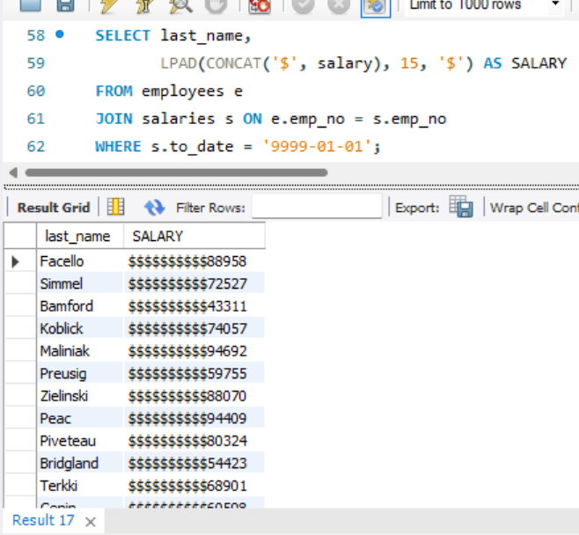
11. Write SQL query for all current employee to show following string:
“<employee last name> earns <salary> monthly but wants <3 times salary>”. Label the column Dream_Salaries.
SELECT CONCAT(last_name, ' earns ', salary,
' monthly but wants ', salary * 3) AS Dream_Salaries
FROM employees e
JOIN salaries s ON e.emp_no = s.emp_no
WHERE s.to_date = '9999-01-01';
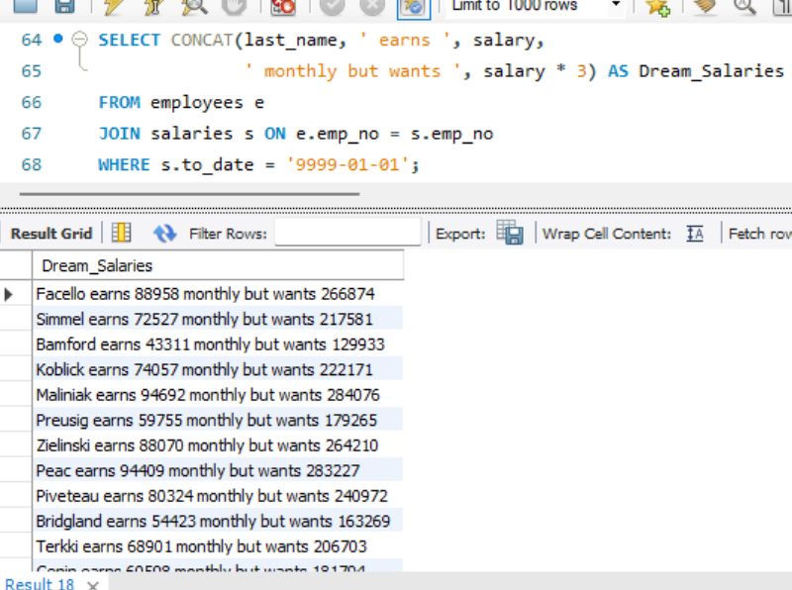
12. Display each current employee’s last name, hire date, and salary review date, which is the first Monday after six months of service. Label the column REVIEW. Format the dates to appear in the format like “Monday, the 31 of July 2000.”
SELECT last_name, hire_date,
DATE_FORMAT(
DATE_ADD(
DATE_ADD(hire_date, INTERVAL 6 MONTH),
INTERVAL (9 - DAYOFWEEK(DATE_ADD(hire_date, INTERVAL 6 MONTH))) % 7 DAY
),
'%W, the %d of %M %Y'
) AS REVIEW
FROM employees;
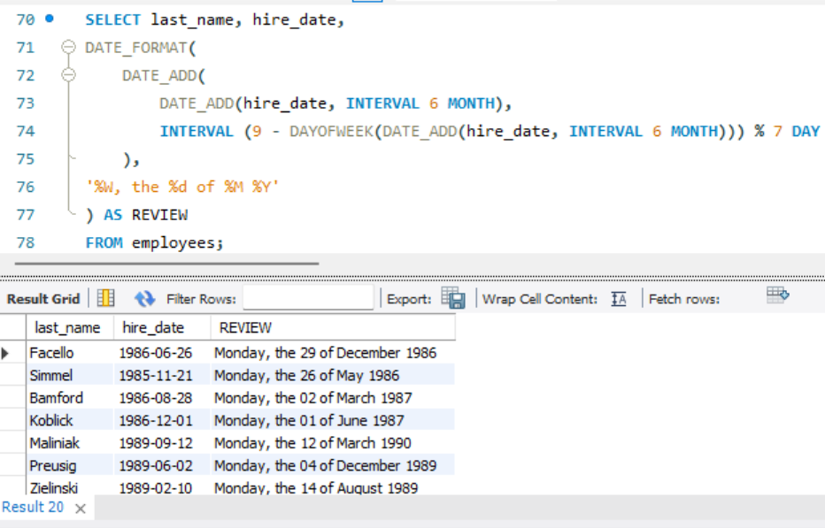
13. Display the last name, hire date, and day of the week on which the employee started. Label the column DAY. Order the results by the day of the week, starting with Monday.
SELECT last_name, hire_date,
DAYNAME(hire_date) AS DAY
FROM employees
ORDER BY FIELD(DAYNAME(hire_date),
'Monday','Tuesday','Wednesday','Thursday','Friday','Saturday','Sunday');
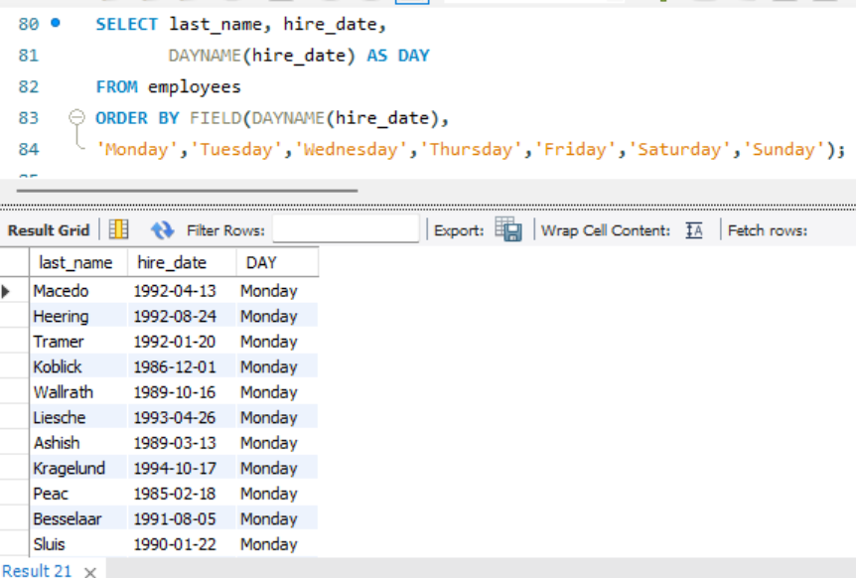
14. Using the CASE syntax, write a query that displays the grade of all current employees based on the value of the column titles from title table, using the following data:
Job_Title Grade
Senior Engineer A
Staff B
Engineer C
Senior Staff D
Assistant Engineer E
Manager 0
SELECT e.emp_no, e.last_name, t.title,
CASE
WHEN t.title = 'Senior Engineer' THEN 'A'
WHEN t.title = 'Staff' THEN 'B'
WHEN t.title = 'Engineer' THEN 'C'
WHEN t.title = 'Senior Staff' THEN 'D'
WHEN t.title = 'Assistant Engineer' THEN 'E'
WHEN t.title = 'Manager' THEN '0'
END AS Grade
FROM employees e
JOIN titles t ON e.emp_no = t.emp_no
WHERE t.to_date = '9999-01-01';
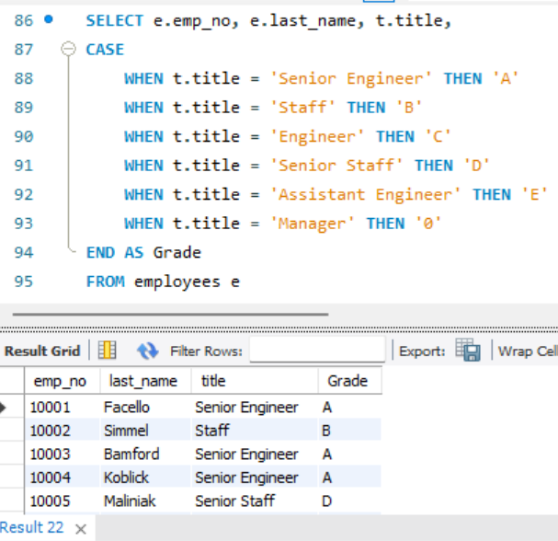
15. Find the highest, lowest, sum, and average salary of all current employees. Label the columns as Maximum, Minimum, Sum, and Average, respectively. Round your results to the nearest whole number.
SELECT
ROUND(MAX(salary)) AS Maximum,
ROUND(MIN(salary)) AS Minimum,
ROUND(SUM(salary)) AS Sum,
ROUND(AVG(salary)) AS Average
FROM salaries
WHERE to_date = '9999-01-01';
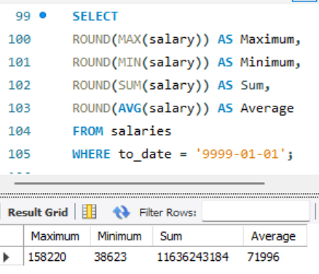
16. Modify the previous query to display the minimum, maximum, sum, and average salary for each job title. Also, have the Job title as a column.
SELECT t.title,
ROUND(MIN(s.salary)) AS Minimum,
ROUND(MAX(s.salary)) AS Maximum,
ROUND(SUM(s.salary)) AS Sum,
ROUND(AVG(s.salary)) AS Average
FROM salaries s
JOIN titles t ON s.emp_no = t.emp_no
WHERE s.to_date = '9999-01-01'
AND t.to_date = '9999-01-01'
GROUP BY t.title;
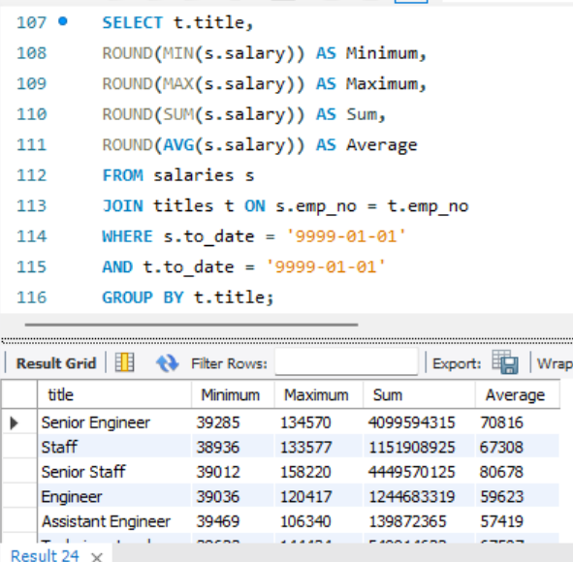
17. Write a query to display the number of current employees with the same job title.
SELECT t.title, COUNT(*) AS emp_count
FROM titles t
WHERE t.to_date = '9999-01-01'
GROUP BY t.title;
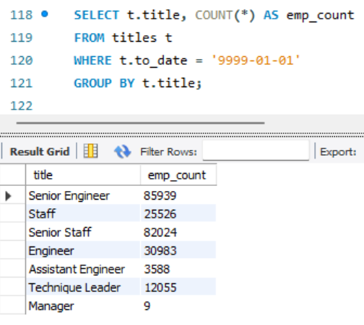
18. Write SQL queries to find the senior current employees (current age > 65). Company decided to offer a retirement bonus of 80% of their current salary. Write SQL query to find all such employees and their current salary and salary after the addition of bonus amount.
SELECT e.emp_no, e.last_name, s.salary,
ROUND(s.salary * 1.8, 2) AS salary_with_bonus
FROM employees e
JOIN salaries s ON e.emp_no = s.emp_no
WHERE s.to_date = '9999-01-01'
AND TIMESTAMPDIFF(YEAR, e.birth_date, CURDATE()) > 65;
